Arduino Lesson 20
1602 LCD Display
- Intro
This test use arduino direct drive.1602 liquid crystal display.1602 display is widely used. The very beginning 1602 display use HD4480 controller, nowadays most of the manufacturer use the compatible IC, so they are basically same.
1602LCD Main Technical Features
Display Capacity: 16 x 2 characters；
Chip Working Voltage: 4.5～5.5V；
Working Current:2.0mA（5.0V）；
Module Best Working Voltage:5.0V；
Character Size:2.95×4.35（W×H）mm
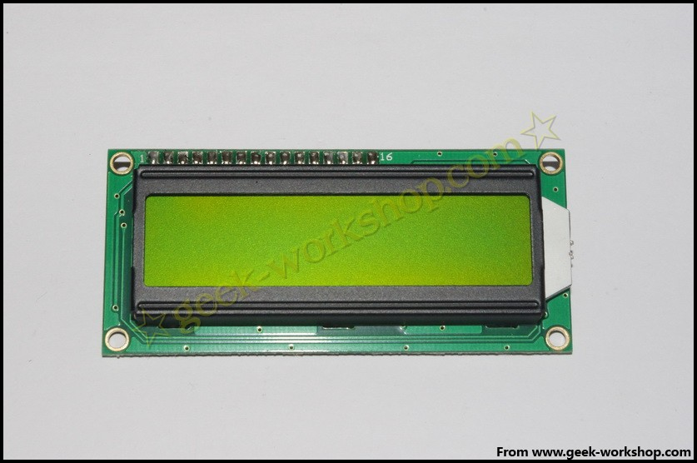

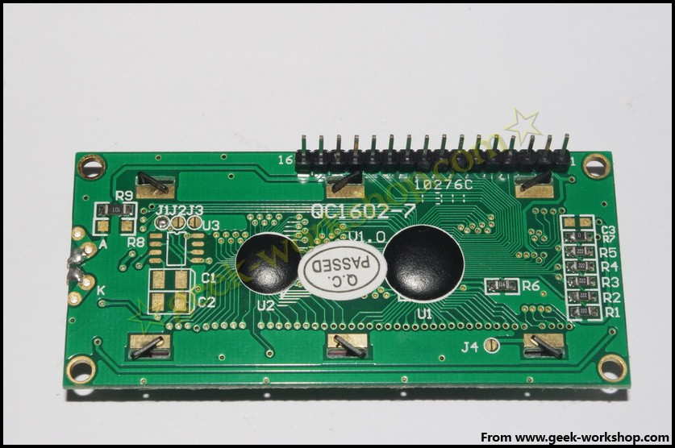
1602 Interface and Pin(contact) instruction
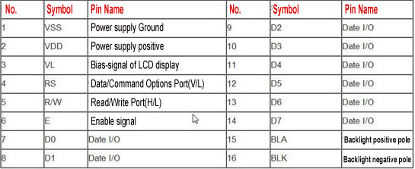
1、Two sets of power supply, one is for module, the other for backlight, normally both use 5v power supply. This experiment use 3.3v.
2、VL is for adjusting contrast ratio by cascading a </= 5kΩ potentiometer. This experiment use a 1KΩ resistor to set up the contrast ratio.The connect types are high potential and low potential.This experiment use the latter, cascade a 1KΩ resistor and access to GND.
3、RS is common on most of lcds. It is data/command options port. It executes data processing when the level is high, execute command when the level is low.
4、RW also common used. It is a reading and writing port. Reading operation initiate when the level is high, writing when level is low.
5、E normally read the data through leaving a positive pulse note after bus signal keep stable.The
bus not allow to be changed when this port stay high level.
6、D0—D7 Eight-bit Two-way parallel bus for sending command and data
7、BLA is backlight positive pole. BLK is backlight negative pole.
4 Types basic operations
1602 communicate directly with Arduino.According to user manual, there are two types of connections, 8-postion and 4-position, we use the former one.
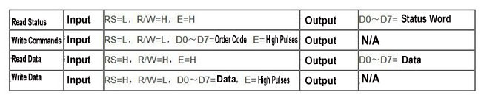
- Connect-it-up
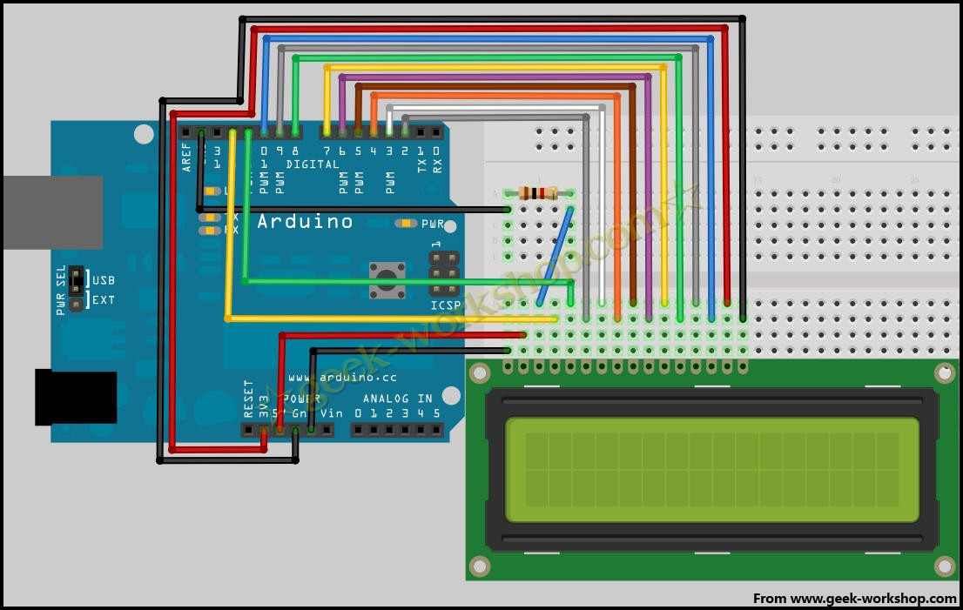
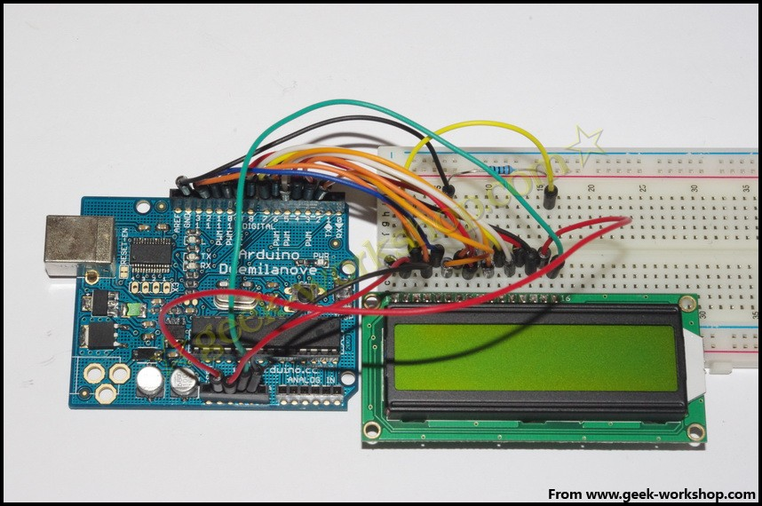
- Program for reference

int DI = 12;
int RW = 11;
int DB[] = {3, 4, 5, 6, 7, 8, 9, 10};//use array to define bus pin
int Enable = 2;

void LcdCommandWrite(int value) {
// define all pin
int i = 0;
for (i=DB[0]; i <= DI; i++) //assign value to bus
{
digitalWrite(i,value & 01);//as 1602 signal identification is D7 to D0(not D0 to D7),here use to invert the signal
value >>= 1;
}
digitalWrite(Enable,LOW);
delayMicroseconds(1);
digitalWrite(Enable,HIGH);
delayMicroseconds(1); // delay 1ms
digitalWrite(Enable,LOW);
delayMicroseconds(1); // delay 1ms
}

void LcdDataWrite(int value) {
// define all pins
int i = 0;
digitalWrite(DI, HIGH);
digitalWrite(RW, LOW);
for (i=DB[0]; i <= DB[7]; i++) {
digitalWrite(i,value & 01);
value >>= 1;
}
digitalWrite(Enable,LOW);
delayMicroseconds(1);
digitalWrite(Enable,HIGH);
delayMicroseconds(1);
digitalWrite(Enable,LOW);
delayMicroseconds(1); // delay 1ms
}

void setup (void) {
int i = 0;
for (i=Enable; i <= DI; i++) {
pinMode(i,OUTPUT);
}
delay(100);
// initialize LCD after temporary pause
// for controlling LCD
LcdCommandWrite(0x38); // set as 8-bit interface，display in 2 rows，5x7 word size
delay(64);
LcdCommandWrite(0x38); // set as 8-bit interface，display in 2 rows，5x7 word size

delay(50);
LcdCommandWrite(0x38); // set as 8-bit interface，display in 2 rows，5x7 word size

delay(20);
LcdCommandWrite(0x06); // set the input way
// automatic increment,no shift display
delay(20);
LcdCommandWrite(0x0E); // display set up
// start display, display cursor, no blink
delay(20);
LcdCommandWrite(0x01); // clear screen,cursor back to zero
delay(100);
LcdCommandWrite(0x80); // display set up
// start display, display cursor, no blink
delay(20);
}

void loop (void) {
LcdCommandWrite(0x01); // clear screen,cursor back to zero
delay(10);
LcdCommandWrite(0x80+3);
delay(10);
// input welcome information
LcdDataWrite('W');
LcdDataWrite('e');
LcdDataWrite('l');
LcdDataWrite('c');
LcdDataWrite('o');
LcdDataWrite('m');
LcdDataWrite('e');
LcdDataWrite(' ');
LcdDataWrite('t');
LcdDataWrite('o');
delay(10);
LcdCommandWrite(0xc0+1); // set cursor position on second row second position
delay(10);
LcdDataWrite('g');
LcdDataWrite('e');
LcdDataWrite('e');
LcdDataWrite('k');
LcdDataWrite('-');
LcdDataWrite('w');
LcdDataWrite('o');
LcdDataWrite('r');
LcdDataWrite('k');
LcdDataWrite('s');
LcdDataWrite('h');
LcdDataWrite('o');
LcdDataWrite('p');
delay(5000);
LcdCommandWrite(0x01); // clear screen,cursor back to zero
delay(10);
LcdDataWrite('I');
LcdDataWrite(' ');
LcdDataWrite('a');
LcdDataWrite('m');
LcdDataWrite(' ');
LcdDataWrite('h');
LcdDataWrite('o');
LcdDataWrite('n');
LcdDataWrite('g');
LcdDataWrite('y');
LcdDataWrite('i');
delay(3000);
LcdCommandWrite(0x02); //set the mode as replacing old words,no change if no new words.
delay(10);
LcdCommandWrite(0x80+5); //set cursor position on row 1 and position 6
delay(10);
LcdDataWrite('t');
LcdDataWrite('h');
LcdDataWrite('e');
LcdDataWrite(' ');
LcdDataWrite('a');
LcdDataWrite('d');
LcdDataWrite('m');
LcdDataWrite('i');
LcdDataWrite('n');
delay(5000);
}
int DI = 12;
int RW = 11;
int DB[] = {3, 4, 5, 6, 7, 8, 9, 10};// use array to define bus pin
int Enable = 2;
void LcdCommandWrite(int value) {
// define all pins
int i = 0;
for (i=DB[0]; i <= DI; i++) //assign value to bus
{
digitalWrite(i,value & 01);// as 1602 signal identification is D7 to D0(not D0 to D7),here use to invert the signal
value >>= 1;
}
digitalWrite(Enable,LOW);
delayMicroseconds(1);
digitalWrite(Enable,HIGH);
delayMicroseconds(1); // delay 1ms
digitalWrite(Enable,LOW);
delayMicroseconds(1); // delay 1ms
}
void LcdDataWrite(int value) {
// define all pins
int i = 0;
digitalWrite(DI, HIGH);
digitalWrite(RW, LOW);
for (i=DB[0]; i <= DB[7]; i++) {
digitalWrite(i,value & 01);
value >>= 1;
}
digitalWrite(Enable,LOW);
delayMicroseconds(1);
digitalWrite(Enable,HIGH);
delayMicroseconds(1);
digitalWrite(Enable,LOW);
delayMicroseconds(1); // delay 1ms
}
void setup (void) {
int i = 0;
for (i=Enable; i <= DI; i++) {
pinMode(i,OUTPUT);
}
delay(100);
// initialize LCD after temporary pause
// for controlling LCD
LcdCommandWrite(0x38); // set as 8-bit interface，display in 2 rows，5x7 word size

delay(64);
LcdCommandWrite(0x38); // set as 8-bit interface，display in 2 rows，5x7 word size

delay(50);
LcdCommandWrite(0x38); // set as 8-bit interface，display in 2 rows，5x7 word size

delay(20);
LcdCommandWrite(0x06); // set the input way
// automatic increment,no shift display
delay(20);
LcdCommandWrite(0x0E); // display set up
// start display, display cursor, no blink
delay(20);
LcdCommandWrite(0x01); // clear screen,cursor back to zero
delay(100);
LcdCommandWrite(0x80); // display set up
// start display, display cursor, no blink
delay(20);
}
void loop (void) {
LcdCommandWrite(0x01); // clear screen,cursor back to zero
delay(10);
LcdCommandWrite(0x80+3);
delay(10);
// input welcome information
LcdDataWrite('W');
LcdDataWrite('e');
LcdDataWrite('l');
LcdDataWrite('c');
LcdDataWrite('o');
LcdDataWrite('m');
LcdDataWrite('e');
LcdDataWrite(' ');
LcdDataWrite('t');
LcdDataWrite('o');
delay(10);
LcdCommandWrite(0xc0+1); // define cursor position on second row and second position delay(10);
LcdDataWrite('g');
LcdDataWrite('e');
LcdDataWrite('e');
LcdDataWrite('k');
LcdDataWrite('-');
LcdDataWrite('w');
LcdDataWrite('o');
LcdDataWrite('r');
LcdDataWrite('k');
LcdDataWrite('s');
LcdDataWrite('h');
LcdDataWrite('o');
LcdDataWrite('p');
delay(5000);
LcdCommandWrite(0x01); // clear screen,cursor back to zero
delay(10);
LcdDataWrite('I');
LcdDataWrite(' ');
LcdDataWrite('a');
LcdDataWrite('m');
LcdDataWrite(' ');
LcdDataWrite('h');
LcdDataWrite('o');
LcdDataWrite('n');
LcdDataWrite('g');
LcdDataWrite('y');
LcdDataWrite('i');
delay(3000);
LcdCommandWrite(0x02); // set the mode as replacing old words,no change if no new words.
delay(10);
LcdCommandWrite(0x80+5); // set cursor position on row 1 and position 6
delay(10);
LcdDataWrite('t');
LcdDataWrite('h');
LcdDataWrite('e');
LcdDataWrite(' ');
LcdDataWrite('a');
LcdDataWrite('d');
LcdDataWrite('m');
LcdDataWrite('i');
LcdDataWrite('n');
delay(5000);
}
4-pos. Connection
Normally 8-pos connections take all the digital port. It is painful If you need more ports for sensors, So 4-pos connection is necessary.

Wiring as below picture shown
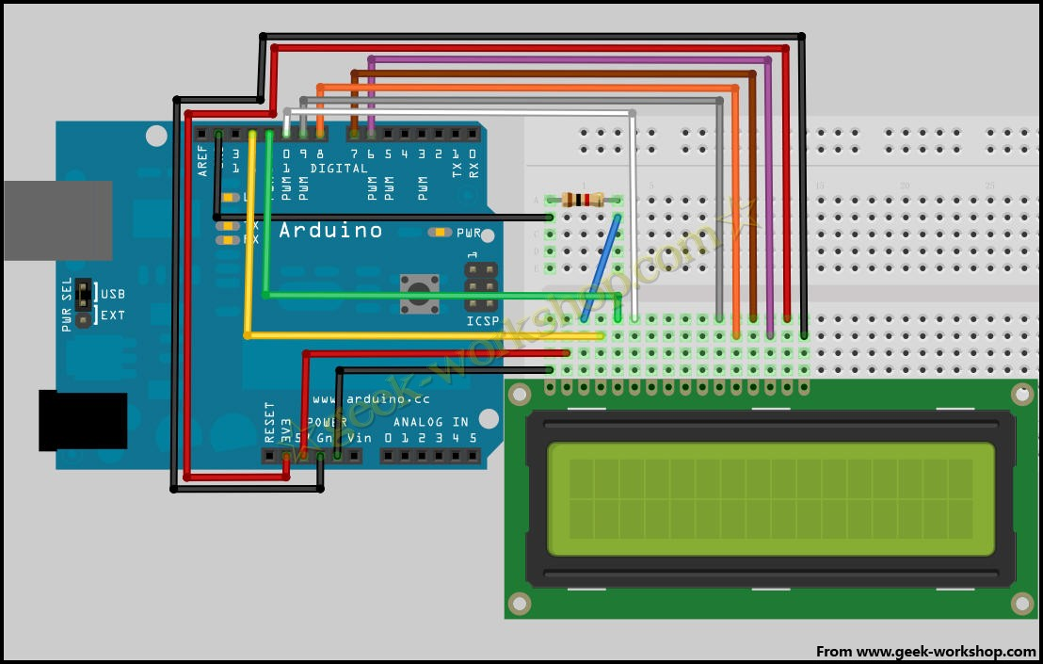
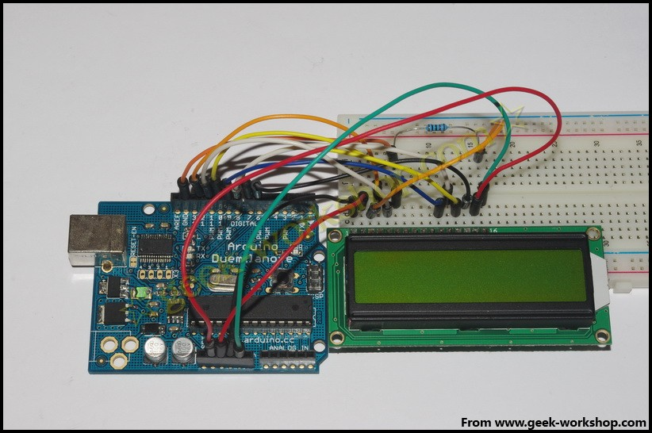

Then download the codes to Arduino too how it work.

int LCD1602_RS=12;
int LCD1602_RW=11;
int LCD1602_EN=10;
int DB[] = { 6, 7, 8, 9};
char str1[]="Welcome to";
char str2[]="geek-workshop";
char str3[]="this is the";
char str4[]="4-bit interface";

void LCD_Command_Write(int command)
{
int i,temp;
digitalWrite( LCD1602_RS,LOW);
digitalWrite( LCD1602_RW,LOW);
digitalWrite( LCD1602_EN,LOW);

temp=command & 0xf0;
for (i=DB[0]; i <= 9; i++)
{
digitalWrite(i,temp & 0x80);
temp <<= 1;
}

digitalWrite( LCD1602_EN,HIGH);
delayMicroseconds(1);
digitalWrite( LCD1602_EN,LOW);

temp=(command & 0x0f)<<4;
for (i=DB[0]; i <= 10; i++)
{
digitalWrite(i,temp & 0x80);
temp <<= 1;
}

digitalWrite( LCD1602_EN,HIGH);
delayMicroseconds(1);
digitalWrite( LCD1602_EN,LOW);
}

void LCD_Data_Write(int dat)
{
int i=0,temp;
digitalWrite( LCD1602_RS,HIGH);
digitalWrite( LCD1602_RW,LOW);
digitalWrite( LCD1602_EN,LOW);

temp=dat & 0xf0;
for (i=DB[0]; i <= 9; i++)
{
digitalWrite(i,temp & 0x80);
temp <<= 1;
}

digitalWrite( LCD1602_EN,HIGH);
delayMicroseconds(1);
digitalWrite( LCD1602_EN,LOW);

temp=(dat & 0x0f)<<4;
for (i=DB[0]; i <= 10; i++)
{
digitalWrite(i,temp & 0x80);
temp <<= 1;
}

digitalWrite( LCD1602_EN,HIGH);
delayMicroseconds(1);
digitalWrite( LCD1602_EN,LOW);
}

void LCD_SET_XY( int x, int y )
{
int address;
if (y ==0) address = 0x80 + x;
else address = 0xC0 + x;
LCD_Command_Write(address);
}

void LCD_Write_Char( int x,int y,int dat)
{
LCD_SET_XY( x, y );
LCD_Data_Write(dat);
}

void LCD_Write_String(int X,int Y,char *s)
{
LCD_SET_XY( X, Y ); //set position
while (*s) //write character string
{
LCD_Data_Write(*s);
s ++;
}
}

void setup (void)
{
int i = 0;
for (i=6; i <= 12; i++)
{
pinMode(i,OUTPUT);
}
delay(100);
LCD_Command_Write(0x28);//4 lines 2 rows 5x7
delay(50);
LCD_Command_Write(0x06);
delay(50);
LCD_Command_Write(0x0c);
delay(50);
LCD_Command_Write(0x80);
delay(50);
LCD_Command_Write(0x01);
delay(50);

}

void loop (void)
{
LCD_Command_Write(0x01);
delay(50);
LCD_Write_String(3,0,str1);//First row, start on fourth position.
delay(50);
LCD_Write_String(1,1,str2);//Second row,start on second position
delay(5000);
LCD_Command_Write(0x01);
delay(50);
LCD_Write_String(0,0,str3);
delay(50);
LCD_Write_String(0,1,str4);
delay(5000);

}
Normally browse, copy codes, store codes,print codes
int LCD1602_RS=12;
int LCD1602_RW=11;
int LCD1602_EN=10;
int DB[] = { 6, 7, 8, 9};
char str1[]="Welcome to";
char str2[]="geek-workshop";
char str3[]="this is the";
char str4[]="4-bit interface";
void LCD_Command_Write(int command)
{
int i,temp;
digitalWrite( LCD1602_RS,LOW);
digitalWrite( LCD1602_RW,LOW);
digitalWrite( LCD1602_EN,LOW);
temp=command & 0xf0;
for (i=DB[0]; i <= 9; i++)
{
digitalWrite(i,temp & 0x80);
temp <<= 1;
}
digitalWrite( LCD1602_EN,HIGH);
delayMicroseconds(1);
digitalWrite( LCD1602_EN,LOW);
temp=(command & 0x0f)<<4;
for (i=DB[0]; i <= 10; i++)
{
digitalWrite(i,temp & 0x80);
temp <<= 1;
}
digitalWrite( LCD1602_EN,HIGH);
delayMicroseconds(1);
digitalWrite( LCD1602_EN,LOW);
}
void LCD_Data_Write(int dat)
{
int i=0,temp;
digitalWrite( LCD1602_RS,HIGH);
digitalWrite( LCD1602_RW,LOW);
digitalWrite( LCD1602_EN,LOW);
temp=dat & 0xf0;
for (i=DB[0]; i <= 9; i++)
{
digitalWrite(i,temp & 0x80);
temp <<= 1;
}
digitalWrite( LCD1602_EN,HIGH);
delayMicroseconds(1);
digitalWrite( LCD1602_EN,LOW);
temp=(dat & 0x0f)<<4;
for (i=DB[0]; i <= 10; i++)
{
digitalWrite(i,temp & 0x80);
temp <<= 1;
}
digitalWrite( LCD1602_EN,HIGH);
delayMicroseconds(1);
digitalWrite( LCD1602_EN,LOW);
}
void LCD_SET_XY( int x, int y )
{
int address;
if (y ==0) address = 0x80 + x;
else address = 0xC0 + x;
LCD_Command_Write(address);
}
void LCD_Write_Char( int x,int y,int dat)
{
LCD_SET_XY( x, y );
LCD_Data_Write(dat);
}
void LCD_Write_String(int X,int Y,char *s)
{
LCD_SET_XY( X, Y ); //set position
while (*s) //write character string
{
LCD_Data_Write(*s);
s ++;
}
}
void setup (void)
{
int i = 0;
for (i=6; i <= 12; i++)
{
pinMode(i,OUTPUT);
}
delay(100);
LCD_Command_Write(0x28);//4lines 2rows 5x7
delay(50);
LCD_Command_Write(0x06);
delay(50);
LCD_Command_Write(0x0c);
delay(50);
LCD_Command_Write(0x80);
delay(50);
LCD_Command_Write(0x01);
delay(50);
}
void loop (void)
{
LCD_Command_Write(0x01);
delay(50);
LCD_Write_String(3,0,str1);// First row, start on fourth position.
delay(50);
LCD_Write_String(1,1,str2);// Second row,start on second position
delay(5000);
LCD_Command_Write(0x01);
delay(50);
LCD_Write_String(0,0,str3);
delay(50);
LCD_Write_String(0,1,str4);
delay(5000);
}

